Room 14’s Scoop --- 3rd of February 2015 --- Term 1
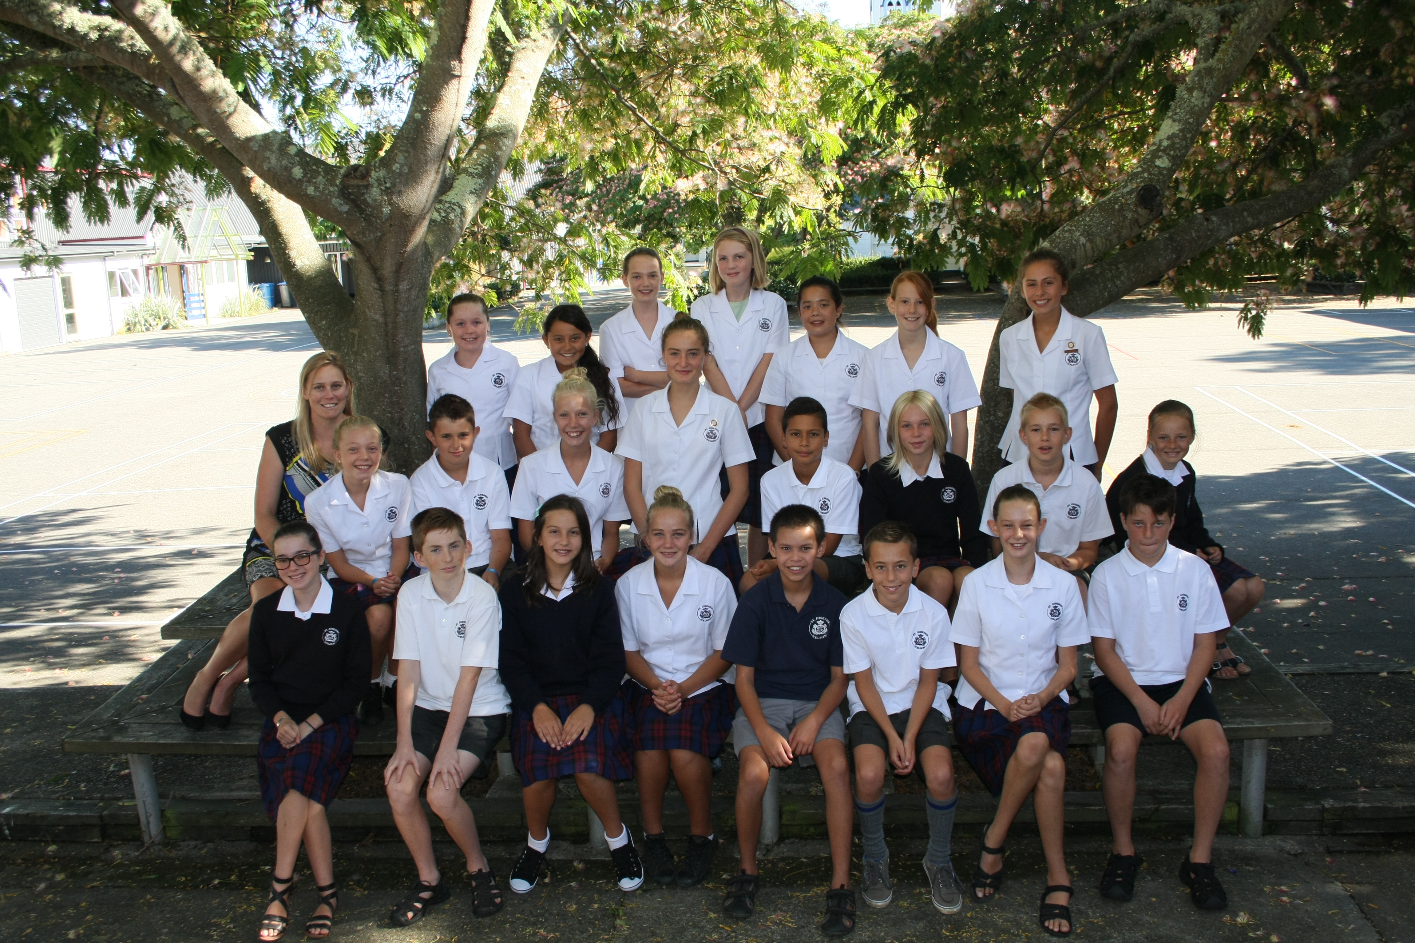 | - Dear Parents and Caregivers,  - Welcome back ! I trust you have all had a relaxing and restful break and are looking forward to the busy and fun term we have planned. I am really looking forward to working with you and your child this year and as there is no formal “meet the teacher” evening this year (because Room’s 13 and 15 are on camp) please feel free to pop in, call or send an email or text  Kind regards, Nicola Hewitt  027 547 3851 --- 03 548 4050 (Office)  nicola@stjosephsnelson.school.nz

About Room 14 …  Our class goal is to maintain a positive environment where we strive to do our best in all areas and we have made a positive start with this already. My expectation is that all Room 14 students practice manaakitanga (the process of showing respect, generosity and care for others) both in class and in the playground.  Home-Study  Home-study is given regularly (usually a two week assignment) and should take approximately 30 - 45 minutes, four days a week. My hope is that this time frame allows plenty of time for students to choose the best time to carry out their learning.  Room 14 students are also expected to take personal responsibility to complete independent study at home. This fosters their self management skills, and in particular, helps them to organise their time around commitments and learn how to produce quality work by a deadline (a life-long skill).  If a student is not meeting the deadlines or not putting in the effort I believe they are capable of, I will contact you. Some students may need help developing their self management skills.  I am most willing to help them ‘chunk’ their work into manageable bites to be completed each night. Work can also be completed in the classroom at lunchtime, if they wish.  Students will not be chased up for late or uncompleted homework. However, I have shared with the students if it is late or not done at all, parents will be notified and this non-commitment to their learning will be reflected in their school reports. Your support with this is appreciated and if there is a reason for your child not having completed their work, I would appreciate a quick note or text. Thank you.  The Arts - Dance/Drama  This will be done in our own class  Languages  Japanese, French and Te Reo are taught to all students in a two week blocks over the course of the year.  Camp  I will be sending a camp notice home later this week. Camp will cost about $200. If you would like to start making payments please use your child’s name, room number and camp as the reference. Thank you.  Technology  Every Wednesday at 8:55am we catch the bus to Nelson Intermediate for Technology. It is essential students are responsible and remember their gear.  Congratulations to Our Councilor’s for Term 1:  Livia Fanselow and Jacoby Stewart have been voted to represent Room 14 this term. This is a fabulous opportunity to develop leadership skills. Eve, Jasmine and Olive are also Christian Services Leaders this year. |  | Students have the choice to work on the presentation of their work when I read to them after lunch.  General Learning  Students are taught to look carefully at the Learning Intention and the Success Criteria that they are working towards (we do go over these in class) and to ensure that these are the focus for their current piece of learning e.g. if it is to write using paragraphs then they need to ensure that they write using paragraphs and not spend hours doing presentation…  English  Through the processes of: Listening, Reading, Viewing, Speaking, Writing and Presenting we will be working to develop the skills of thinking critically and reflectively, responding to our own writing and the writings of others, showing an awareness of purpose and personal voice and developing understanding of how sentences, paragraphs and images contribute to and affect the meaning in texts. We will also be working on extending our choice of vocabulary and comprehension. Writing, reading, spelling and listening skills will be assessed in class.  Mathematics and Statistics  Our Maths programme is based on Numeracy. The emphasis in this programme is developing problem-solving strategies in a hands on way. The students are divided into four bands, (selected on a needs basis).  Having a sound base of basic facts is essential & I will be testing this and will inform you if extra work at home on this would be beneficial to your child.  Buddy Class  We are so lucky at our school to have the opportunity to develop leadership skills and one area we can do this is our fortnightly visits to our buddy class.  ICT BYOD (Bring Your Own Devices)  If your child has not yetsigned the Internet Agreement form. If your child has their own device, we strongly encourage them to bring them and use them on their learning at school. A lockable cupboard is provided.  Health and Physical Education  Aquatic and water safety skills and games for understanding (invasion, target and striking games).  If for any reason your child will not participating during PE please let me know via text, email or note. It is our expectation if there is no note explain why they are unable to participate in physical activity – they will. Your support is appreciated with this.  If you are available to assist the Intermediate students with sport coaching on a Friday afternoon 2:00 – 2:50 we would be very grateful.

Things to note …  - If your child is away from school please phone the school office or email me an email or text.  nicola@stjosephsnelson.school.nz --- 027 547 3851  - Students are expected to wear the correct school uniform each day and this includes a sun hat in the summer months. We do have a “no hat – no play” policy.  - A note or email must be sent if your child is unable to participate in physical activity.  - Togs and PE uniform must come to school everyday.  Students should be reading a chapter book and they need to have this at school each day. We do visit the school library each Monday afternoon. |  | Dates to note …  - Syndicate Swimming Sports - 27 February at 1:45pm  - Suter Mural Walk, Monday, 9 March  - Cycle Safety, Tuesday 17 March  - Interschool Swimming Sports, Friday, 13 March at Nayland Swimming Pool  - Novelty Swimming Sports, Friday, 13 March at NIS  - Hiwi the Kiwi Performance $4  - Marahau Camp - 29 March to 2 April (last week of term)

………………………………………………………………………….…...………………………………………………………………………….…...

Reply Slip Term 1 Newsletter 2015 - please return this slip by Thursday, 12 February 2015 – Thank you.

I/we think it would be helpful to have a “Meet the Teacher” meeting later in the term yes / no

I give permission for ………………………………………….. to take part in the above mentioned activities.

 | Name |  | Signature

